**REST WEB SERIVCE**

**Get Started**

* Visit <https://start.spring.io/>
* Dependencies *“****Spring web starter****”, “****Spring data JPA****” and “****PosgreSQL driver****”*
* Import file to eclipse or Spring tools
* Create new package “.controller”



* Create new class *“BrandController”*
* *Add Annotation @RestController @RequestMapping*("[url]")

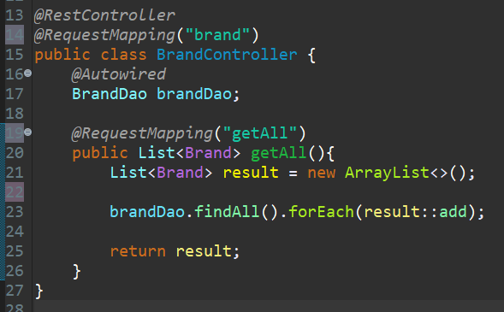

* Open postman and insert localhost url -> klick ***send***



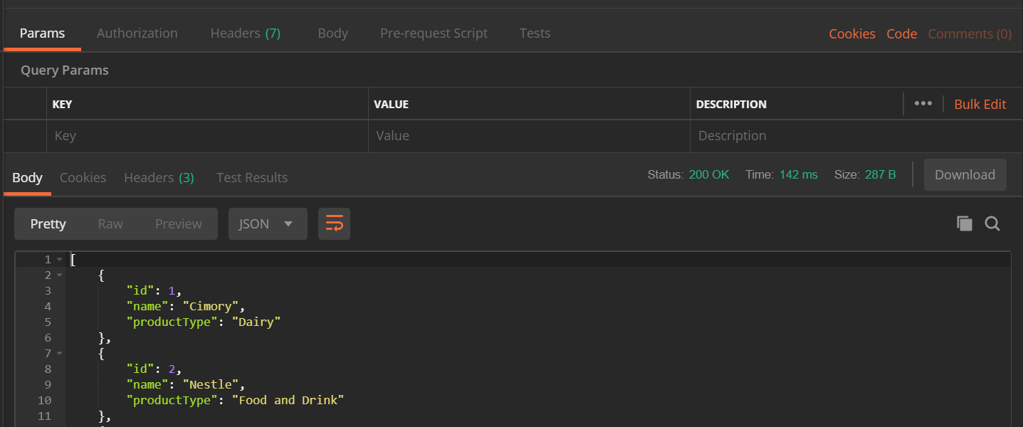

* Method to find data by id with parameter “*id”*

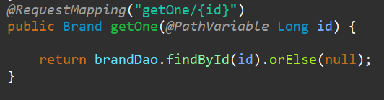

* Method to save

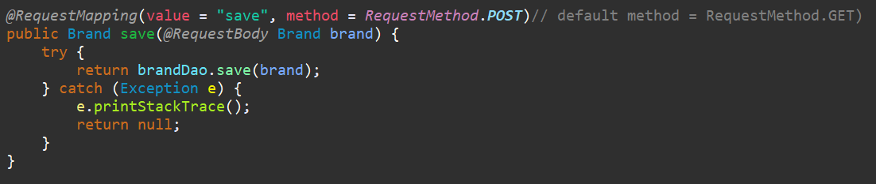

* Method Update

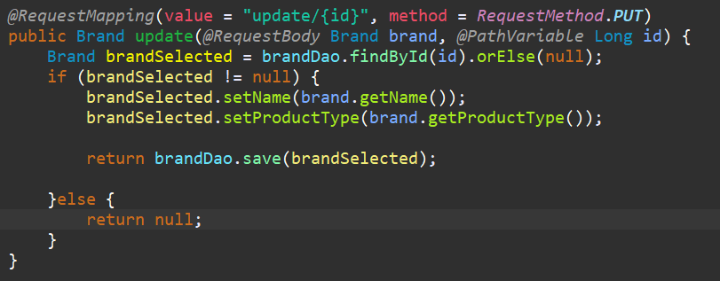

* Method delete